Version 1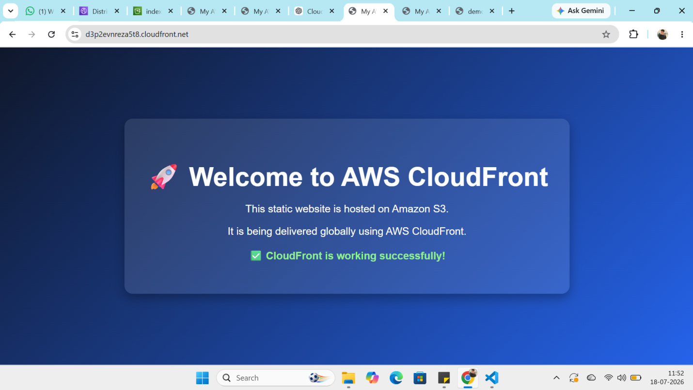
Version 2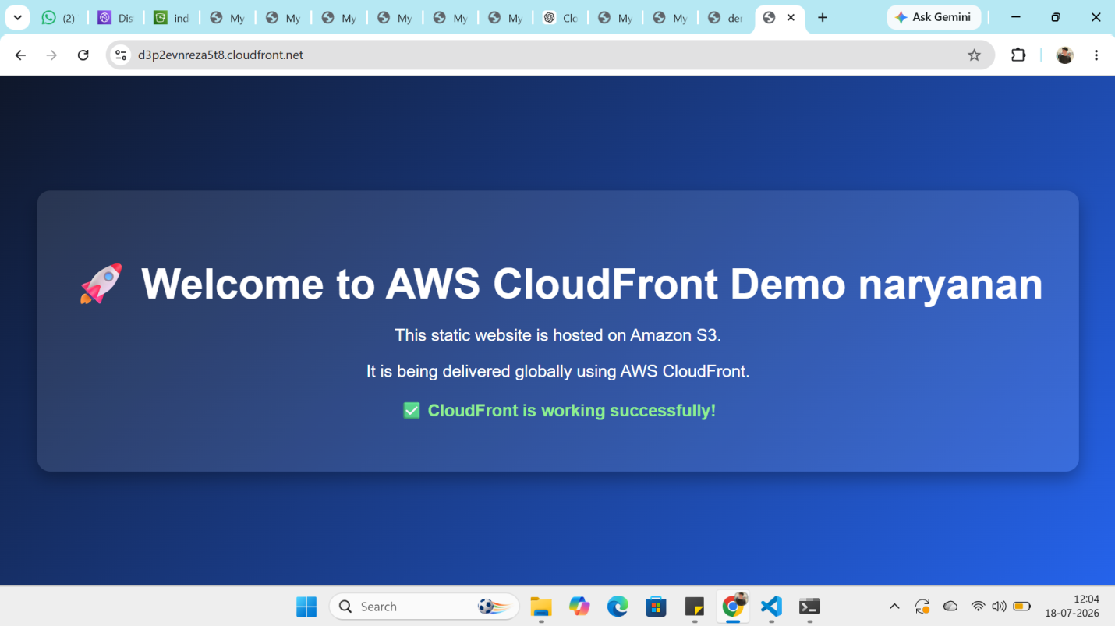
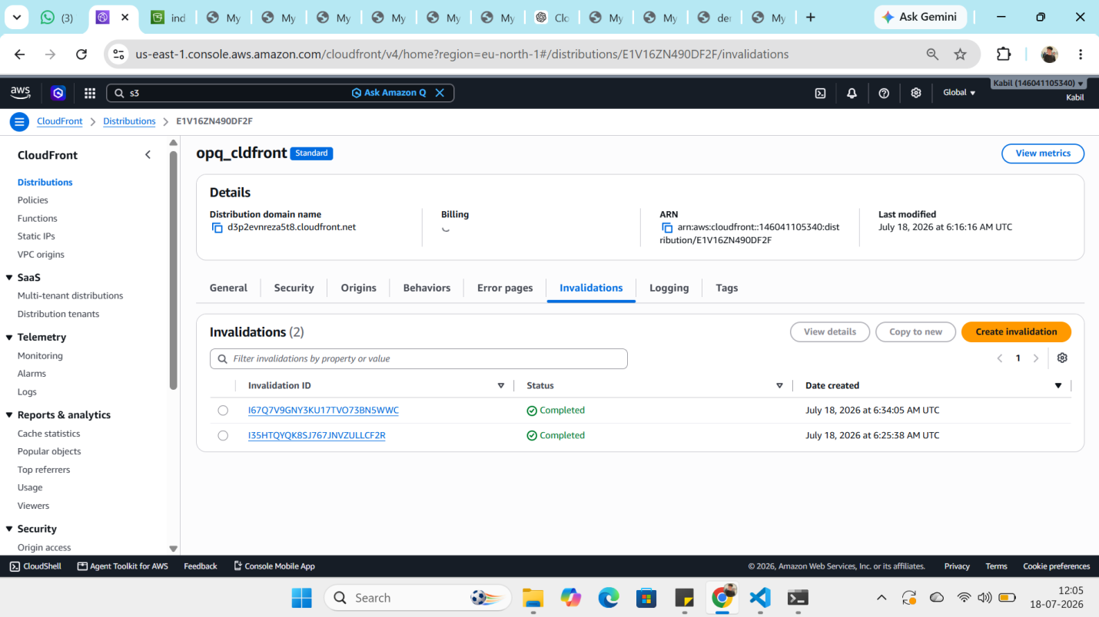

AWS CloudFront with S3 – Step-by-Step
Step 1: Create an S3 bucket, enable Versioning, and upload index.html file (Version 1).
Step 2: Create a CloudFront distribution and select the S3 bucket as the Origin. Enable Origin Access Control (OAC) so that CloudFront can securely access the files in the S3 bucket. AWS automatically updates the bucket policy.
Step 3: After the distribution is created, edit the distribution settings and set the Default Root Object to index.html. This allows to access website using only the CloudFront URL.
Step 4: Open the CloudFront URL in your browser. Version 1.
Step 5: changes to index.html (Version 2) and upload it to the same S3 bucket. If refresh the CloudFront URL immediately, still see Version 1 because CloudFront is serving the cached content from the edge locations.
Step 6: To display the latest content immediately, create an Invalidation in the CloudFront distribution (invalidate /index.html or /*). This clears the old cached copy from all edge locations.
Step 7: Refresh the CloudFront URL again. CloudFront fetches the updated index.html from the S3 bucket, caches the new version, and displays Version 2.

